NOTES; COMMUNICATIVE ENGLISH

What is Communication?
The English word ‘communication’ is derived from the Latin communis, which means common sense. The word communication means sharing the same ideas. In other words, the transmission and interaction of facts, ideas, opinions, feelings or attitudes. Communication is the essence of management. The basic function of management (planning, planning, staffing, supervision and management) cannot be done effectively without effective communication.

Communication is a two-way process which involves transferring of information or messages from one person or group to another. This process goes on and includes a minimum of one sender and receiver to pass on the messages. These messages can either be any ideas, imagination, emotions, or thoughts.

Communication is a Latin word which means “to share”. There are different modes of communication available today. These include emails, chats, WhatsApp, skype (conference calls), etc. Effective communication makes people’s work easier and smooth.

Communication Process
Communication is an ongoing process that mainly involves three components namely. sender, message, and recipient. The components involved in the communication process are described below in detail:
- Sender:
The sender or contact generates the message and transmits it to the recipient. He is the source and the first contact
- Message:
It is an idea, knowledge, opinion, truth, feeling, etc. produced by the sender and intended for reference.
- Encoding:
The message produced by the sender is encrypted in a symbolic way such as words, pictures, touches, etc. before transfer.
- The media:
This is how the coded message is conveyed. The message can be conveyed orally or in writing.
- Recording:
It is a process of modifying the signals sent by the sender. After recording the message is received by the recipient.
- Recipient:
You are the last person in the chain and the message you sent was sent. If the recipient receives the message and understands it correctly and acts on the message, only then the purpose of the communication is achieved.
- Answer:
Once the recipient confirms to the sender that you received the message and understood it, the communication process is complete.
- Noise:
Refers to any restrictions caused by the sender, message or recipient during the communication process. For example, incorrect telephone connection, incorrect coding, incorrect recording, careless recipient, incorrect understanding of message due to discrimination or inappropriate touch, etc.

Types of Communication
Verbal Communication and Non-Communication
- Verbal communication:
Communication occurs through verbal, verbal or written communication that conveys or conveys a message to others is called oral communication. Verbal communication is the use of language to convey information verbally or in sign language.Verbal communication is important because it works well. It can be helpful to support verbal Non-verbal communication Any non-verbal communication, spoken words, conversation and written language ​​is called.

- Non-verbal communication:
It occurs with signs, symbols, colors, touches, body or facial features. Insignificant communication is using body language, body language and facial expressions to convey information to others. It can be used both intentionally and deliberately. For example, you may have a smile on your face when you hear an idea or a piece of interesting or exciting information. Open communication is helpful when you are trying to understand the thoughts and feelings of others.

Mode Of Communication
- Formal Communication:
Formal Communication refers to communication that takes place through legal channels in an organization. That kind of communication takes place between managers or employees of the same class or between high and low and vice versa. It may be oral or written but a complete record of that communication is kept in the organization.

- Informal Communication:
Informal communication is defined as any communication that occurs outside of the official channels of communication. Informal communication is often referred to as the ‘vine’ as it spreads throughout the organization and on all sides regardless of the level of authority.

Few Communication Barriers
One sometimes wants to connect with one thing, but he is actually saying something else that he did not intend. This type of event in communication behaviour is known as the “Arc of Distortion”. The distortion may be the result of some error in any of the communication channels. These barriers to communication are also known as “barriers”.
Some of the barriers to communication:
- Lack of proper style, feedback.
- Content is not related to customer requirements.
- Failure to maintain dual communication.
- Bad weather.
- Lack of horizontal flow of ideas.
- Availability of technical coordinators.
- Semantic Problems.
- Lack of leadership.
- Lack of enthusiasm.
- Lack of support from heads of institutions.

Importance of Communication
- Communication Foundation:
The manager explains to the employees the goals of the organization, the methods of their success and the interpersonal relationships between them. This provides communication between the various staff and departments. Therefore, communication serves as the basis for collaboration in the organization.
- Functional:
The manager coordinates the individual and physical aspects of the organization in order to run it efficiently and effectively. This integration is not possible without proper communication.
- The Basis for Making Decisions:
Good communication provides information to the manager that helps them make decisions. No decisions could have been made without knowledge. Thus, communication is the basis for making the right decisions.
- Improves Management Ability:
The manager transfers targets and issues instructions and assigns tasks to subordinates. All of these factors are involved.

Importance of Communication
Communication plays a vital part in building up a strong relationship across the world, either in organisational structure or outside of it. It is an essential pillar for people in sharing the ideas, delegating responsibilities, management of a team, building up a healthy relationship, etc. Effective communication is necessary for managers in the organisation for planning, organising, leading and controlling. Managers of the organisation are dedicated enough in communicating throughout the day in various tasks performances. They spent the whole time communicating face-to-face or over the phone to their colleagues, subordinates and the clients. Managers also use written communication in the form of Emails, memos, daily reports and so on. Effective communication is a successful building block of the organisational structure.

Here The Importance of Communication Can Be Briefed As Follows
- Good communication encourages motivational skills.
- It is a mode of information in the decision-making process.
- Communication emphasises socialising within or outside the organisational structure.
- It helps in controlling the process. Employees have to follow the organisation rule, code of conduct and other company policies.

Types of Communication
There are four types of communication. It is categorised into verbal, non-verbal, written and visual.

Verbal
Verbal communication is one of the modes where people communicate or transfer information through words. It is one of the common and usual types and frequently used during one on one presentations, video calls or conferences, meetings, phone calls etc.

There Are Certain Measures Which Enhance This More Effectively
- Firm and Confident Voice:
Firm and confident communication reflects the personality of the person. It gives more certainty of completing any task. So always be confident so that your ideas are more precise and specific.
- Active listening:
A good listener always tends to listen to everyone’s perspective or viewpoints. Active listening helps in identifying each one’s problem or thoughts in a more clear way.
- Ignore Filler Words:
While giving a presentation, avoid using filler words such as yeah, like, so, etc. It might be distracting to your audiences. Try not to use them in official conferences or meetings.

Non-Verbal
Non-verbal communication is the use of body language. It includes body gestures, facial expression, and shaking hands, etc.. For example: How you sit during an interview automatically reflects your body language. If they are indicating closed body language like closed arms, bent shoulders, shaking legs, etc., they might be nervous, low in confidence, surrounded with anxiety, etc. Non-verbal communication is the most powerful communication to understand others’ thoughts and emotions.

Here are Certain Categories Where Non-Verbal Communication are Briefed Up
- Positive Body Language: Always carry a positive body language where you can carry your confidence for performing any task. This type of communication gives support to your verbal talks and makes you more open to any kind of jobs.
- Imitate non-verbal communication you find useful: Some facial expression or body language can be found helpful in an interview. If an interviewer has positively nodded his head, it gives a clear positive sign in a closed way, i.e. non-verbal communication.

Written
It is the form of communication that involves writing, typing and printing symbols, letters, etc. It is used in Emails, chats, etc. which are the common techniques of using it in the workplace. Whereas it also furnishes a record of all docs in one place and keeps a systematic account of it.

Here Are Certain Categories Where Written Communication is Briefed Up
- Aim for Simplicity:
Any type of written communications should be in a simple format and clear. It helps audiences to understand and provides more transparency on information which you're providing.
- Reviewing:
Whenever you're writing, always review your emails, letters or memos before sending it. Reviewing helps to find the mistakes or opportunities to present something distinct.
- Be Careful of Written Tone:
Since this is not a mode of verbal or non-verbal communication, always be cautious and have a polite tone while writing.
- Keep the Written Files if You Find it Useful:
If you received the memo or email which you’re finding helpful or interesting, you could save that template for further references to use it in future writing for improving your written communication.

Visual
Visualizing is a form of communication where one can use photographs, drawing charts and graphs to convey information through it. It helps in furnishing the right information through graphics and visuals during office presentation (along with verbal and written).

Here are Certain Steps Which Help in Visual Communication Skills
- Taking Advice Before Going with Visuals:
Visual communication includes presentation or emails. Always ask for other’s advice if any mistake can be rectified.
- Targeting Audience:
Always put those visuals in presentation or emails that can be understood by everyone quickly. If you are giving a presentation on any data or chart which is not familiar to the audience, you need to explain it clearly. There shouldn’t be any usage of offensive visuals.

Barriers in Communication
There are certain barriers which create hindrance in building up communication over the time period.
- Personal Barriers:
Communication takes place between receiver and sender. It’s a two-way process which should be clear. In case message formation went wrong, it gives a wrong and unclear message to the recipient. The receiver might get the wrong perspective while receiving a message. Therefore the message should be written effortlessly.
- Systematic Barrier:
If any machine or electronic errors occur by any means or in any unforeseen situation, it may affect the importance of communication.

Flow of Communication
An organisation follows the five flow of communications:
- Downward Flow:
In this, communication flows from the higher level to lower level, i.e. communication carried out by the head of the organisation to the subordinates like providing feedback, giving job instructions etc.
- Upward Flow:
Communication which flows to the higher level of the organisation is upward communication. Subordinates use upward flow to transfer their grievances and performances to their seniors.
- Lateral/Horizontal Communication:
It takes place where communication happens between the same level of the hierarchy that is communication between colleagues, managers or between any horizontally equivalent members of the organisation. It benefits employees to perform coordination among the tasks, time-saving, solving problems of employees of other departments or conflicts within the department.
- Diagonal Communication:
Communication which takes place between the manager and employee of other work departments is known as diagonal communication.
- External Communication:
Communication which takes place between the manager and external group likes vendors, suppliers, banks, financial institutions and many more. For example, the Managing Director would be meeting with the bank manager to get the bank loan or some other financial work.

What is Interpersonal Communication

What Is Interpersonal Communication?
Interpersonal communication involves the information, ideas, and feelings being exchanged verbally or non-verbally between two or more people. Face-to-face communication often involves hearing, seeing, and feeling body language, facial expressions, and gestures.
In other terms, Interpersonal communication is exchanging information, meaning, feelings, and opinions between two or more people via verbal and non-verbal means. Although we mentioned “face-to-face” communication previously, today’s technology compels us to expand its definition to include media such as phone calls and online messaging.

What About Intrapersonal Communication?
You may have heard the term “intrapersonal communication” and wondered if it’s related to interpersonal communication. The words are opposites, actually. “Inter” refers to dealings between people, groups, or other entities (e.g., intercontinental, international). “Intra,” on the other hand, describes actions within a person or a group. For example, an intranet is a private digital network that exists solely within a company or organization.
Intrapersonal communication describes how we communicate with ourselves, including an accurate idea of our perceptions, expectations, and concepts.

Types of Interpersonal Communication
The first step in answering “what is interpersonal communication?” is breaking it down into four distinct types.
- Verbal: In other words, speaking. This term covers the words you use, how persuasively you speak, the language you use, which words you emphasize, and even the use of affirmative sounds and short phrases like “Yup” or “Uh-huh.”
- Listening: You can make a good case for listening as the most important interpersonal communication skill. It covers the ability to listen attentively, whether you’re using your ears to listen “in-person” or some other means, say, over the Internet. Listening also includes special techniques like reflection and clarification. The best listeners are people who can focus their attention on the speaker to make the latter feel like they're the sole and most important person in the room.
- The Written Word: Thanks to the Internet age and situations requiring isolation (e.g., the pandemic), good written communication skills have become an asset. Whether you're on social media, in the workplace, or even texting on your phone, you must know how to get your point across in writing. This type includes emojis, grammar, clarity, tone, and even punctuation. After all, there's a vast difference between "Let's eat, Grandma!" and "Let's eat Grandma!"
- Non-Verbal: This final type covers body language, facial expressions, tone of voice, and gestures. Again, it's essential that the listener picks up and correctly interprets non-verbal cues.

The Importance of Interpersonal Communication
Interpersonal communication is a valuable "soft skill" in many job descriptions. Strong interpersonal communication skills help people better express their emotions and thoughts and cultivate a stronger sense of empathy for others.
Interpersonal communication is also a vital part of being a team player or a group leader, things that recruiters are always looking for.
If you have solid interpersonal communication skills, you can clearly express your intentions and thoughts, enriching your professional relationships and personal life.
So many conflicts stem from simple misunderstandings. Strong interpersonal communication skills help reduce the likelihood of these misunderstandings, which subsequently lowers the risk of arguments, hurt feelings, grudges, and problems with morale.
What is Intrapersonal Communication?
Communications expert Leonard Shedletsky examined intrapersonal communication through the eight basic components of the communication process (i.e., source, receiver, message, channel, feedback, environment, context, and interference) as transactional, but all the interaction occurs within the individual (Shedletsky, 1989).
From planning to problem solving, internal conflict resolution, and evaluations and judgments of self and others, we communicate with ourselves through intrapersonal communication.
All this interaction takes place in the mind without externalization, and all of it relies on previous interaction with the external world.
Intrapersonal communication is the process by which an individual communicates within themselves, acting as both sender and receiver of messages, and encompasses the use of unspoken words to consciously engage in self-talk and inner speech.[1]

Intrapersonal communication, also referred to as internal monologue, autocommunication, self-talk, inner speech, or internal discourse, is a person's inner voice which provides a running monologue of thoughts while they are conscious.[2] It is usually tied to a person's sense of self. It is particularly important in planning, problem solving, self-reflection, self-image, critical thinking, emotions,[3] and subvocalization (reading in one's head). As a result, it is relevant to a number of mental disorders, such as depression, and treatments like cognitive behavioral therapy which seek to alleviate symptoms by providing strategies to regulate cognitive behaviour. It may reflect both conscious and subconscious beliefs.[2]

Intrapersonal communication is a broad concept, encompassing all types of internal communication, including for example the biological, and electrochemical communication that occurs between neurons and hormones.[4] Intrapersonal communication is also typical for religious or artistic works. Prayers, mantras and diaries are good examples. In organisations and corporations, strategic plans and memos, for example, can function like mantras. But any text (or work) can become autocommunicational if it is able to be memorized and recited.

Intrapersonal communication provides individuals with the opportunity to participate in "imaginative interactions", by which they silently engage in conversation with another person, often as a means of selecting and rehearsing their intended spoken interpersonal communication with the actual person.[5][6]

Intrapersonal communication also facilitates the process by which an individual engages in unspoken internal dialogue between different and sometimes conflicting attitudes, thoughts, and feelings, often as a way of resolving psychological conflicts and making decisions.[7]
Phonetics is the study of the sounds of speech. It is concerned with the physical properties of speech sounds or signs (phones): their physiological production, acoustic properties, auditory perception, and neurophysiological status. Phonology, on the other hand, is concerned with the abstract, grammatical characterization of systems of sounds or signs.
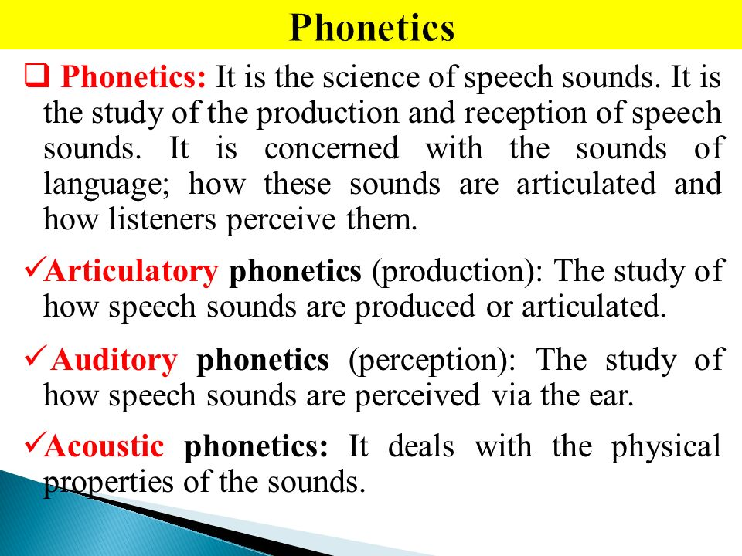.
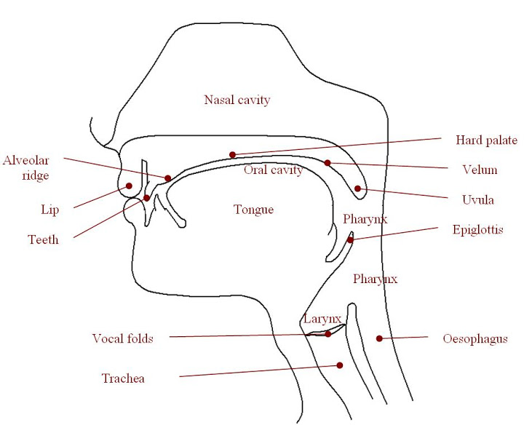

A person who specializes in phonetics is known as phonetician.
Phonetic Symbols
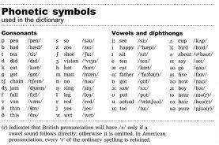
The above picture gives us an idea about phonetic symbols.
Branches of Phonetics:
Phonetics can be divided into three main branches. They are as follows:
1. Articulatory Phonetics: it is a study which involves the use of vocal cords to produce a speech sound.
2. Acoustics Phonetics: It involves the study of physical properties of speech sound.
3. Auditory Phonetics: It involves the study of the way people recognize speech sounds.
The Importance of Phonetics:
When we open an English dictionary we find that there is a sign just before or after the word, and these signs are called phonetics. Phonetics are very important because they help you improve your pronunciation.
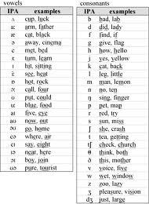

What is a syllable ? – Examples:
A syllable is a single, unbroken vowel sound within a spoken word. They typically contain a vowel, or two if one is silent, and perhaps one or more accompanying consonants. All words are made from at least one syllable.
Syllables are sometimes referred to as the 'beats' of a word that form its rhythm, and breaking a word into syllables can help English learners with phonetic spelling. Another way to describe a syllable is a 'mouthful' of a word!

Since we’ve answered the question of ‘what is a syllable in English?’, it’s time for us to witness them in action. Below are some examples of words with different numbers of syllables:
- 'Tie' has one syllable.
- 'Rescue' has two syllables - Res + cue
- 'Alphabet' has three syllables - Al + pha + bet
- 'Activity' has four syllables - Ac + tiv + i + ty
- 'Electricity' has five syllables - E + lec + tri + ci + ty
A word with only one syllable can be called monosyllabic. There are names for other syllable amounts in words too: disyllabic for two, trisyllabic for three and quadrisyllabic for four. Or, you can just refer to them as polysyllabic if they have more than one!
An important thing to note is that the length of the word doesn't affect the number of syllables it has. It's all about the number of vowel sounds.

What are the six types of syllables?
Next up in our journey of learning ‘what is a syllable in English?’, we’ll learn about the different kinds of syllable. While there are two main types of syllables, closed and open, there can also be split into six different kinds. Let’s learn a bit about what these are:
1) Closed Syllable
A closed syllable is a word unit with a single vowel that ends with a consonant. These have a short sound such as bat, plant, shop and rabbit.

2) Open Syllable
An open syllable is a word unit that ends with a single vowel such as go, me, you and potato.
There are more types of syllables that you might come across in more advanced grammar, including:
- magic 'e' or vowel-consonant -e;
- R-controlled syllables;
- diphthong (vowel team);
- and consonant 'le'.
3) Vowel-consonant-e Syllable (VCE)
These syllables end in a final silent 'e' (hence why they're nicknamed magic 'e' syllables) with a consonant just before the silent 'e'. The silent 'e' makes the vowel before the consonant have a long sound. Here are some examples:
- line
- cute
- mine
- pine
- mute
- home
This syllable is usually taught after children are familiar with short and long sounds, as well as closed and open syllables. Here's a teaching tip for you: to transition from closed syllables to VCE words, try adding a silent 'E' to CVC words. For example, 'hat' becomes 'hate' and 'tap' becomes 'tape'.
4) R-controlled Syllable (VR)
In r-controlled syllable words, there's always a vowel followed by an 'r'. The 'r' gives the word a unique sound. Examples of VR words:
- her
- fur
- ear
- for
- purr
This kind of syllable is taught after open, closed and VCE syllables.
5) Diphthong (vowel team) Syllable
A diphthong syllable usually has two vowels next to each other which are pronounced together, which is why they're dubbed 'vowel teams' - the vowels work together as a syllable. The vowel combinations are typically:
- ai
- ay
- ow
- oe
- ie
- ee
- oi
- ea
- oa
Here are examples of words with diphthong syllables:
- tail;
- play;
- grow;
- oboe;
- eight;
- meet;
- beat;
- boat.

In some words, there are two vowels next to each other, but the combination is reversed when compared to a diphthong syllable where the vowels are pronounced together.
For example, many words have the vowel combination 'io' in them, such as the word 'lion'. With these vowel combinations, you split the syllable between 'i' and 'o' so that the word actually has two syllables. These syllables are still known as vowel teams.
6) Consonant 'le' Syllable
These syllables have no vowel sound - the silent 'e' at the end of the syllable works as the only vowel. You only pronounce the consonant and the 'l'. Examples of words with the 'le' syllable:
- maple
- purple
- turtle
- ripple
- circle
- cycle
- table

Silent letters in English
The English language is full of words whose written form can be deceptive. Unlike a language like Spanish, in English we rarely sound out all the letters that we see.
The result is a series of words which are written in a way which seems very different from their sound. Lots of these strange ‘silent’ letters are due to the history of the English language. Not only has it absorbed plenty of vocabulary from invaders, like French, Latin and Norse, but the eventual standardization of sounds in the English language has meant that certain words, whilst keeping their older forms of spelling, have had their sounds refined and softened.

What is your English level?
Take our short English test to find out.
START NOW
Thanks to this development of the language, we are now left with hundreds and hundreds of English words which have some surprising silent letters. Here we take a look at some common words with silent letters, and how to pronounce them.

The silent K: You need to know
The ‘k’ in English is traditionally a hard-sounding vowel ‘cah’ or ‘kah’, especially when it’s at the end of a word: back, for instance. However, when the letter ‘k’ precedes the letter ‘n’ at the start of a word, it falls silent; such as ‘know’. Know’ is interesting, because even though the ‘k’ is silent (we don’t say ‘cah-noh’), it is not pronounced the same way as ‘now’.
- ‘Know’ = noh. ‘Now’ = naow.
Here’s a few words which have a silent k at the start and a hard k later on: knock, knack, knapsack, knickers, knuckle.

The silent P: Psychology with no receipt
The ‘p’, usually a popping sound made at the front of the mouth, is silenced when it precedes an ‘s’. Most of these words with silent ‘p’s are to do with the mind or the medicine of the mind: Psychology, psychiatry, psyche, psychological, psychotic or pseudo.
Indeed, when p or ‘ps’ starts a word it is almost always medical. This is thanks to its Greek origins. ‘Pneumonia’ – caused when you catch excessive cold – also has a silent p, so it is pronounced ‘new-moan-ee-a’.
Finally, you’ll every now and then find a silent p in the middle of a word, such as ‘receipt’. In English we say ‘re-seet’, with no ‘p’ sounding in the second syllable, though some would argue that the p is there to slightly soften the sound.
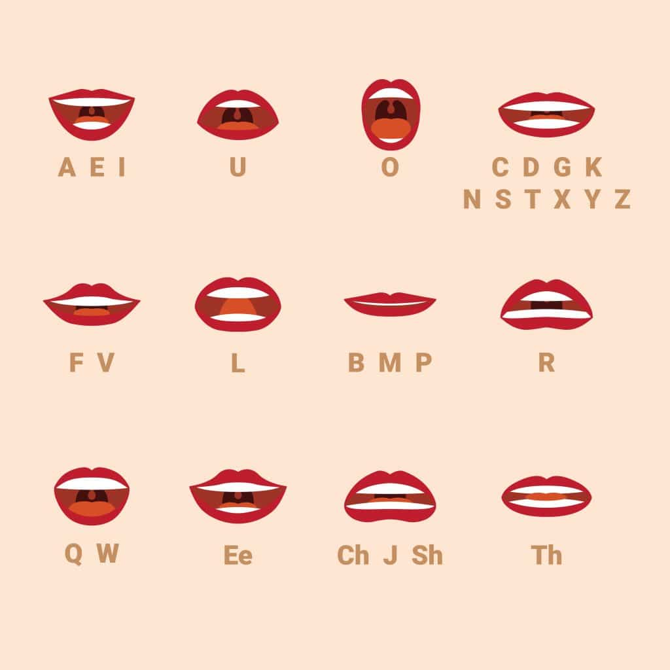

The silent c: Miscellaneous muscle
A bit like the ‘k’, the ‘c’ is usually a hard sound (unless followed by an ‘h’; ‘ch’ is soft, think ‘cheese’, ‘cheers’). However, when following an ‘s’ it is often silent.
- ‘Muscle’ – we say the same as ‘mussel’, the seafood.
- ‘Miscellaneous’ – pronounced ‘mis- sell- lay – nee – ous’.
Whilst you do not hear the c, it does slightly change the sound. ‘Scene’ for instance, has the first sound slightly further forward in the mouth than ‘seen’, it’s rhyme. Likewise, the ‘c’ works in slightly softening what would otherwise be a very hard, hissy ‘ss’ sound. Other key words with silent ‘c’s include: ascend, ascent/descent, fascinate, fluorescent, incandescent, obscene, scene, scenario or scented.

The silent g: Benign gnomes
This is one of our favourites. There are many words which sound normal, and should be spelt in a normal simple way – and all of a sudden there’s a ‘g’ in there. ‘Foreign’ is a classic example – the only thing ‘foreign’ in that word is the ‘g’!
We don’t sound the hard ‘guh’ sound of the ‘g’ in these words, but its inclusion does give a slight lengthening of the vowel sound – ‘for-reyn’.
Here’s a few more examples: gnome, benign, malign, design, deign, gnash, sign…
A great example of how the ‘silent’ g isn’t quite silent; if we didn’t pronounce the ‘g’ at all, this would be ‘sin’. However, the ‘g’ lightens and elongates the vowel sound – to be pronounced ‘sigh-n’. This is true for all ‘ign’ words – imagine that the ‘ign’ sounds like ‘sigh’ (de-sigh-n; mal-ighn).
Learn English today with the world’s largest online school: EF English Live. We provide support, structure and help achieve your goals. Start learning English today!


The silent b: A bomb with aplomb
There are plenty of words in the English language that smuggle in a ‘b’ where it’s not needed, supposedly.
The silent b, usually coming after an m, is not pronounced ‘b’ as it would normally be at the front of a word (‘boy’). However, as with most of these examples, it does soften and slightly elongate the word – so whereas ‘tomb’ would sound like ‘toh-m’ or the name ‘Tom’ is we just took out the b, ‘tomb’ is pronounced ‘tooh-m’.
Here are some key examples: climb, comb, crumb, debt, thumb, tomb or womb.

The silent n: Damn solemn autumn
Not dissimilar to the silent b, the silent n usually appears after an ‘m’ and is not pronounced ‘nuh’ as an ‘n’ normally is, but simply functions to soften the words final vowel sound a little. The ‘n’ is silenced, within the mouth, but it makes these words subtly longer than if they just ended in ‘m’: hymn, damn, solemn, condemn or column.

The silent t: A whistle! Listen!
Ah the confusing silent ‘t’. The ‘t’ – ‘tuh’ sound – is one of the most recognisable and strong sounds in the English language – yet in the middle of ‘listen’, it disappears!
Instead the ‘t’ becomes a little like another, slightly shorter ‘s’: listen becomes ‘lissen’; whistle is ‘whissle’ etc. Here’s a few more: hustle, jostle, apostle, bristle, thistle or wrestle.

